Task-8:

Minimize docker image size for enhanced containerization.

Steps:

Create one instance, login server (I am using Git Bash).

Aws ec2-instance

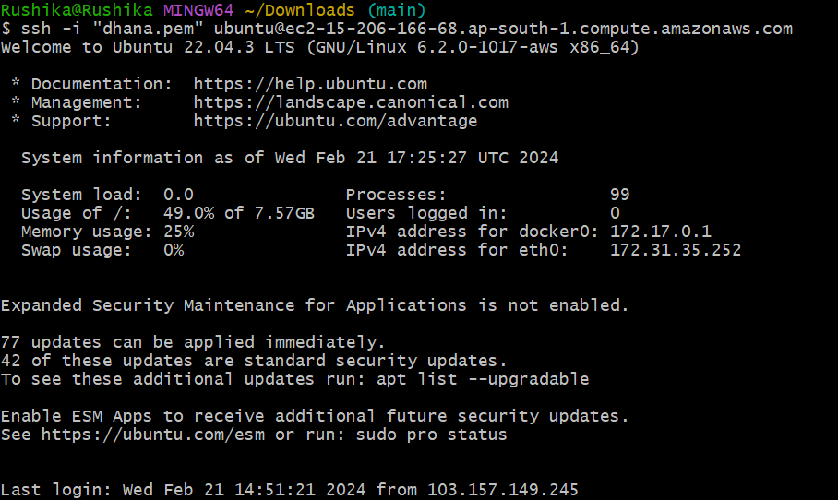

Install docker in ubuntu server (<https://docs.docker.com/engine/install/ubuntu/>)

Docker version



Next, clone git repo

(git clone https://github.com/dhana0803/Docker-Zero-to-Hero.git )

This is my docker file

Using ubuntu image, golang-go application.

Docker file

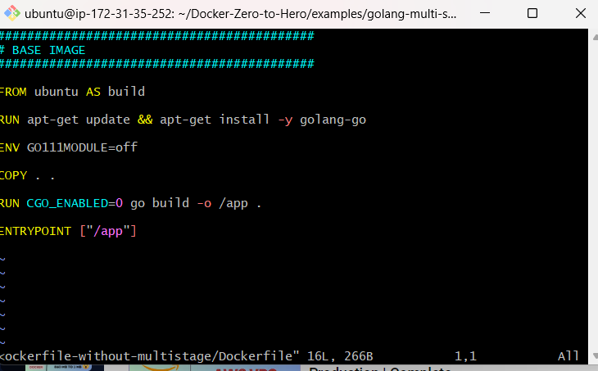

build docker file

using this command (docker build -t image1 .)

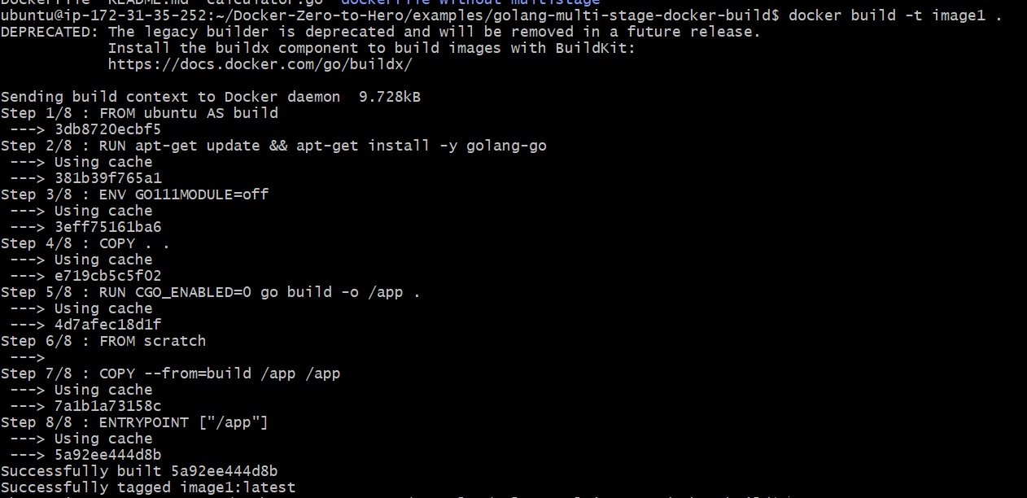

Docker image size

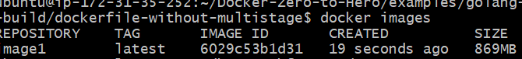

Reduce my image size using multi stage build.

Multi stage build docker file

Docker image size (image1: 869MB)

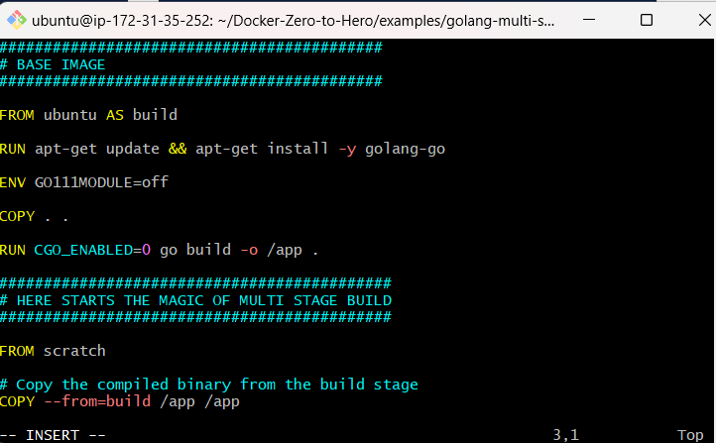

Docker build multi stage build

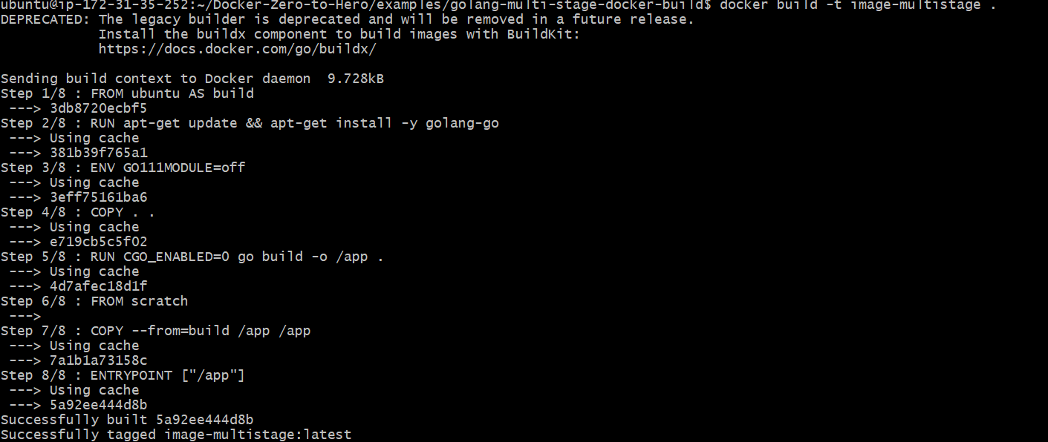

Image size



Docker image size (image-multisize:1.83MB)

Reduce image size (869MB-1.83MB)